Technical Vocabulary

⚙️ What is Technical Vocabulary
# Source: AI Source: Provided by: [Data Path: Persons Table -> ID Column: 1, Name_En Column: Motasem Essam] -> From: [Chatgpt (GPT-4-turbo)] on [7/30/2025]
Technical vocabulary consists of specialized words and expressions used within a particular field or profession. These terms carry precise meanings understood by experts or practitioners in that domain and are often not commonly used in everyday conversation.

✅ Key Features:
# Source: AI Source: Provided by: [Data Path: Persons Table -> ID Column: 1, Name_En Column: Motasem Essam] -> From: [Chatgpt (GPT-4-turbo)] on [7/30/2025]
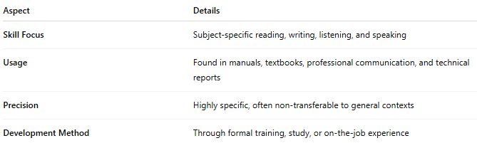
Aspect | Details
Skill Focus | Subject-specific reading, writing, listening, and speaking
Usage | Found in manuals, textbooks, professional communication, and technical reports
Precision | Highly specific, often non-transferable to general contexts
Development Method | Through formal training, study, or on-the-job experience

🧠 Examples by Field:
# Source: AI Source: Provided by: [Data Path: Persons Table -> ID Column: 1, Name_En Column: Motasem Essam] -> From: [Chatgpt (GPT-4-turbo)] on [7/30/2025]
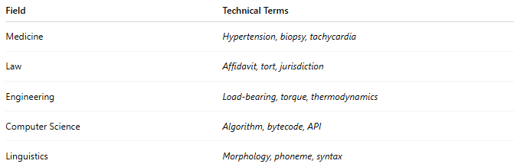
Field | Technical Terms
Medicine | Hypertension, biopsy, tachycardia
Law | Affidavit, tort, jurisdiction
Engineering | Load-bearing, torque, thermodynamics
Computer Science | Algorithm, bytecode, API
Linguistics | Morphology, phoneme, syntax

👤 Who Uses It?
# Source: AI Source: Provided by: [Data Path: Persons Table -> ID Column: 1, Name_En Column: Motasem Essam] -> From: [Chatgpt (GPT-4-turbo)] on [7/30/2025]
- Professionals in technical or academic careers
- Students in specialized programs
- Researchers and scientists
- Manual and instruction readers
- Industry experts

📌 Related Vocabulary Types:
# Source: AI Source: Provided by: [Data Path: Persons Table -> ID Column: 1, Name_En Column: Motasem Essam] -> From: [Chatgpt (GPT-4-turbo)] on [7/30/2025]
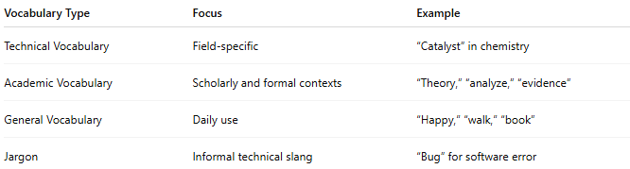

Vocabulary Type | Focus | Example
Technical Vocabulary | Field-specific | “Catalyst” in chemistry
Academic Vocabulary | Scholarly and formal contexts | “Theory,” “analyze,” “evidence”
General Vocabulary | Daily use | “Happy,” “walk,” “book”
Jargon | Informal technical slang | “Bug” for software error

